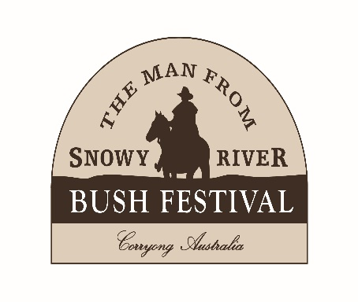
2026 VICTORIAN BUSH POETRY CHAMPIONSHIPS
16th-19th April
ADULT WRITTEN ENTRY FORM
Entries Close Friday 27th February 2026

NAME:

ADDRESS:

POSTCODE: EMAIL:

MOBILE: HOME:

Entry Fee: $10.00 per poem, up to three entries in Sect 1 & 2 (Males & Females judged together).
(Typed, double spaced, 1 side A4 paper only. Max 120 lines. 3 copies ea. poem with cover sheet.(*NB* A “Cover Sheet” contains the poem section entered (i.e. Humorous or Serious) the poem’s name, the poem’s line count, the authors name, address and phone number). No names on actual poems please. Authors names on actual poems will lead to automatic disqualification from this competition.
No critiques will be provided in 2026.

Judging Sheets for Sections 1 & 2 can be found at www.abpa.org.au/events.html

WRITTEN SECTIONS

SECTION ONE: VBPC Open Written Original Serious - Silver Brumby Poetry Award
1st - $150 & Trophy 2nd- $70 3rd - $30

1. POEM TITLE:

2. POEM TITLE:

3.POEM TITLE:

SECTION TWO: VBPC Open Written Original Humorous - Corryong Larrikin Award
1st - $150 & Trophy 2nd- $70 3rd - $30

1. POEM TITLE:

2. POEM TITLE:

3. POEM TITLE:

VBPC Overall Written Champion - $1000
There is no fee to enter this award. Its results are determined from the aggregate scores compiled in sections 1 & 2.
VPBC Novice Written Champion – $50
Determined by highest aggregate scores. No entry fee.

PAGE 1/2

TERMS AND CONDITIONS OF ENTRY
- Entrants should be prepared to provide a photo and details for publication if required.
- We reserve the right to publish, record or reproduce work submitted, Copyright ©, is retained by the writer.
- We reserve the right to alter the program if necessary (at any time).
- Judges and anyone paid by the MFSR Bush Festival are ineligible for prizes in Sections 1 & 2
- Critiques will not be provided in 2026.
- Judge’s decisions for both the Performance & Written sections of the competition are final and no correspondence will be entered into. Harassment of any judge or official (by contestants) before, during or after the competition (whether said harassment be either verbal, written or electronic) will not be accepted or tolerated. Harassment of any sort will see the perpetrator banned from entering said Victorian Bush Poetry Championships for a period of 3 years!

In light of the recent increase in AI generated text and documents and to guard against plagiarism in our 2026 Written Sections ALL WRITTEN ENTRIES will be run through the “Turnitin” programme App for our 2026 event to safeguard everybody concerned. Authors submitting entries for the 2 Written Sections of our competition in 2026 should be aware of this fact and accept this procedure as part of their entry process. By signing the ‘Declaration’ on page 2 of the “Adult Written Entry Form” authors are declaring that all written poems submitted are WHOLLY ORIGINAL IN CONTENT and contain no text generated by an AI programme or text plagiarised from other authors past or present. Work discovered to contain AI generated or plagiarised text will be AUTOMATICALLY DISQUALIFIED from our 2026 written competitions. (Entry fees will not be refunded under these circumstances).

DECLARATION
- I have read and agree to abide by the Terms and Conditions of Entry. Entries are my own original work and have not won me a 1st prize at any Victorian State or ABPA National Championships.
- I ALLOW / DO NOT ALLOW my work (© mine) to be used for Festival promotion (please circle).
- I declare that Poetry is (please circle) HOBBY OR My ABN is:
- I declare my status is (please circle) OPEN NOVICE
- Novice: Gained no more than 2 x 1st places in any competition in 2 consecutive years.

Signature: ______________________________________ Date: ____________

ENTRY FEES
I enclose completed entry form and payment of:
Entries: ($10 ea.) ______________Total: ______________

Payment can be made by:
Direct Deposit:
Account Name: MFSRBF Income Account
BSB: 633 000 Account Number: 1536 14573 Reference: Your surname & ‘Poet’ (e.g. Martin, Poet).

PAGE 2/3

Entry Forms: Post hard copy entry form, 3 copies of each poem & cover sheets to:
2026 MFSR Written Bush Poetry Competition
P.O. Box 655, West Ryde, NSW, 1685
Email: TheRhymerfromRyde@bigpond.com

EXTRA INFORMATION
If you would like the competition results mailed to you, please include A4 sized, stamped, self-addressed envelope (2 x $1.70 stamps). No envelope = No posted results. Sorry!
The judges’ assessment sheets for the TOP 10 written Humorous & Serious poems ONLY will be posted to contestants after the conclusion of the festival

All sections held Thurs, Friday, Saturday and Sunday at the Lions Youth Hall/Banjo’s Block. All awards presented on Sunday afternoon the 19th April 2026.
Programs, when available, can be purchased at the festival or accessed at www.bushfestival.com.au

If you have any questions, please contact the Poetry Co-Ordinator Graeme Johnson on 0419415137 or e-mail, TheRhymerfromRyde@bigpond.com

*NB* All information contained in this document was correct at time of publication. Any changes to this document will be updated in newer versions of said document on the websites contained within.

PAGE 3/3

