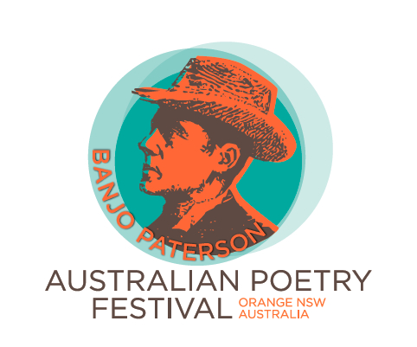
Banjo Paterson Australian Poetry Competition 2024
For individual performance of original poetry
Performance and judging will be on Friday 23 February 2024 at the Orange Ex Services Club, Anson Street, Orange NSW. Performance times will be advised when entries are collated.

Classes:
- High School students – for contestants who are attending high school in 2024.
- Primary School students – for contestants who are attending primary school in 2024.
- Novice – for adults who have not won a poetry performance competition.
- Open – for all adults.

Prizes:
Class 1. High School: first prize $100; second prize $75; third prize $50
Class 2. Primary School: first prize $100; second prize $75; third prize $50
Class 3. Novice: first prize $200; second prize $100; third prize $75
Class 3. Open: first prize $250; second prize $150; third prize $100

Conditions of entry:
- Poems are to be original works.
- Poems should generally be rhyming verse.
- Poems and performances are not to be offensive and must be suitable for family entertainment.
- Poems are to be performed by the poet, in person, at the event.
- The performance may include reciting or reading.
- The maximum presentation time is 8 minutes per entry for the Open Class and 5 minutes per entry for the other classes (preamble and postscript are included in the time limit).
- Entrants are to provide their own equipment and props. A microphone and lectern will
be available on stage.
- Judging will be based on how well the poem is written and how well it is performed.
- Entrants may enter one Class only.
- Entrants may enter one poem only.
- Poems performed in previous Banjo Paterson Australian Poetry Competitions, Orange, must not be entered in this 2024 competition. Poets that have placed (1st, 2nd, or 3rd) in any poetry competition in the previous 2 years cannot perform the same winning poems in this 2024 competition, as it aims to foster original poetry and support novice or new performers in all categories - competing poets should exercise integrity in this matter.
- There is no need to submit a written copy of the poem.
- Entry is free for Classes school students and $10 per entry for adults.
- Entries close at 5 pm on Monday 12 February 2024.
- Entrants will be notified by email before Monday 19 February 2024 of their performance time.

Post or email entry forms to: Direct deposit entry fees to:
Mr D Stanley Rotary Club of Orange Project Account
8 Poate Street BSB: 082 774
WINDRADYNE NSW 2795 Account number: 50985 7605
dstanle5@outlook.com Please include ‘BP and your name’ as a reference
Contact person: David Stanley dstanle5@outlook.com 0428 894 571
or Len Banks banks@lmbanks.com.au 0428 459 117

Banjo Paterson Australian Poetry Competition 2024
ENTRY FORM

Please use one entry form per contestant.
Entries close 5 pm Monday 12 February 2024.

Name of poet/contestant:

Postal address:

Email address:

Contact phone number:

High School entry (title):

Primary School entry (title):

Novice entry (title):

Open entry (title):

I agree to the conditions of entry. Signature of contestant…………………………..

Signature of parent/guardian for students………………………….

Date……………………………….

Post or email entry forms to: Direct deposit entry fees to:
Mr D Stanley Rotary Club of Orange Project Account
8 Poate Street BSB: 082 774
WINDRADYNE NSW 2795 Account number: 50985 7605
dstanle5@outlook.com Please include ‘BP and your name’ as a reference

